**Prerequisites to Use Figma**

1. **Email Account**
2. **Good Internet Connection**
3. **Good browser**

**Wire framing with Figma**

Wireframes are diagrams that depict the structure of a design, and they can be either low-fidelity (for user research) or mid-fidelity (for UX research). We’ll be focusing on the latter (UX research), and visuals will be of no concern to us here, because all we want to do at this stage is figure out the content and layout (otherwise known as the “information architecture”).

**What are we wire framing?**

First, a little background on the UI we’ll be building. It will be a table-like structure showing various UX design tools and which step of the UX design workflow each tool is used in. The data will be user-submitted, so the aim is to see which UX design workflow is best, rather the overdone “which UI design tool is best?”

Wire framing will help me to figure out how best to structure this interface without wasting time on figuring out the little visual details. It won’t look amazing, but that’s fine; it just needs to look nice enough that users can offer me some feedback.

Yes, it’s a real UI. At the moment I’m calling it “Tool flows”.

1. Download the beta version of the Figma Desktop app: ...
2. Figma will download the app to the location you have configured. ...
3. Move the Figma icon from the Downloads folder to your Applications folder.
4. Delete the Installer from your Desktop or Downloads folder.
5. Open the Figma Beta app to get started.

**Step 1: Set Up the Artboard**

The majority of my website’s users are desktop users, so it makes sense to wireframe my design on a desktop artboard. Press A on your keyboard, then click Design > Desktop > MacBookfrom the right sidebar of Figma.

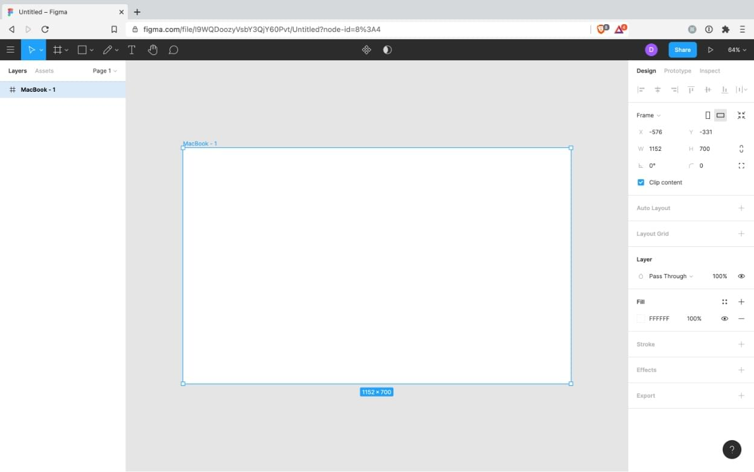

Step 2: Gather Functional Requirements

Assuming that you or somebody else did some user research at some stage, we’ll need to refer to that to create our wireframe. While conducting user research (specifically, user interviews, focus groups, and user testing with low-fidelity wireframes), we would have been made aware of any functional requirements.

Ours are:

filter by tool

number of workflow users

Let’s start wireframing!

Step 3: Create Text and Shapes

First of all, there are Figma wireframe kitsavailable, but I’m not a fan of them exactly. They make me feel constrained to work only with what’s available in the kit, so it hinders creativity.

Instead, we’ll wireframe using text and shapes.

As we learned before with the artboard, the easiest way to create anything in Figma is to abuse the keyboard shortcuts:

T: Text

O: Ellipse

R: Rectangle

⇧⌘K: Image

⇧L: Arrow

L: Line

After that, it’s simply a case of clicking on the artboard roughly where you’d like the object to appear, and then you can use your mouse and arrow keys to adjust the size and alignment.

Useful shortcuts:

⌘-/+ to Zoom.

⌘D to Duplicate selected objects.

⌘G to Group selected objects (⌘rc to select within).

Hold ⌘ when mouse-resizing to rotate objects.

Hold ⇧ when mouse-resizing to maintain aspect ratio.

Use arrow keys to move objects by 1px (Hold ⇧ for 10px).

Arrow keys + ⌘ to resize by 1px (Hold ⌘⇧ for 10px).

